CS-007 Wet Layup & Vacuum Bagging
Doc ID | CS-007
Title | Wet Layup & Vacuum Bagging
Revision | C
Status | Draft, pending Lead signature (photos to add at first SN6 use)
Effective date | 2026-08-28
Supersedes | Verbal wet-layup training

Approvals
Role | Name | Date
Author | Simon Starbuck (drafted with Claude, SN6 Resources) | 2026-07-12
Reviewer | simon (reviewer agent)
Approver (Composites Lead)

Revision history
Rev | Date | Author | Description of change
A | 2026-07-12 | Claude | Initial outline
B | 2026-07-28 | Claude | Language pass: fewer em dashes for rhythm variety, no content change.
C | 2026-08-28 | Claude | Out of outline, engineering pass (CS-000 Rev C conventions). §7's ten numbered lines became a procedure with subsections; every number in it was already in Rev B or its references, so nothing was invented, only unpacked. §4 definitions written out. Figure 1 draws the bag stack with the breather clearance rule, the one that turns a bagged part into a bagged part glued to its breather. Photo placeholders stay until the first SN6 wet layup.

1. Purpose
Wet layup is our second core process (seat, flat panels, foam-wrapped wing elements). In SN5 the knowledge was verbal plus one Slack SOP; this doc writes it down with the numbers attached.

2. Scope
Hand lamination with West System 105, vacuum-bagged, on molds (CS-004-prepped), flat plates, and foam cores (foam-wrapped wing elements). Infusion: CS-006.

3. References
Ref | Document | Where
R1 | West 105/206 TDS (5:1 by volume; pot life 20–25 min @72 °F; thin-film cure 10–15 h) | 04 Datasheets/WEST_SYSTEM_105_Epoxy_Resin_with_206_Slow_Hardener.pdf
R2 | West 105/205 TDS (fast: pot life 9–12 min) | 04 Datasheets/WestSystems-105-205-Epoxy-Resin.pdf
R3 | VB160 film, PP180 peel ply, breather | 04 Datasheets/
R4 | CS-002 (stack), CS-004 (mold prep), CS-008 (mixing/exotherm) | this series
R5 | Simon's layup SOP (Slack, 2026-05-30): 105 "big tank, blue label" + 206 "large metal can, red label", 5:1 | Slack record

4. Definitions
- Wet-out: cloth fully saturated by resin: uniform sheen, weave still visible. Swimming in resin is past wet-out, not better.
- Breather: lofted bleed cloth between peel ply and bag. It gives air a path to the vacuum port and absorbs excess resin. It is kept clear of part edges it could bond to; resin that wicks into breather at an edge glues it on.
- Bridging: bag film spanning a corner instead of following it. Under vacuum a bridge either punctures or leaves a resin-rich void at the corner. Pleats exist to prevent it.
- 60:40: target cured fiber:resin ratio by weight. The mix factor in §7.2 deliberately overshoots it; squeegee and breather carry the excess out.

5. Equipment & Materials
West 105 + 206 (default) or 205 (small parts), calibrated pumps (5:1 by volume, R1) or scale (weight ratios in R1: 5.36:1 for 206), brushes/rollers/squeegees, peel ply, breather, VB160, tacky tape, vacuum pump + trap + gauge.

6. Safety
Per West SDS + team rules: nitrile gloves (sensitizer; same warning as CS-004 §6), ventilation, no solvent on skin; exotherm rules per CS-008 (105/205 in a pot gets hot fast). Respirator with A-filter for large overhead/enclosed laminating.

7. Procedure

7.1 Prerequisites
- Stack frozen and printed on the WO (CS-002 §7.2). Mold sealed and released per CS-004 with its quality checks passed, or plate waxed, or foam core shaped and dry-fitted.
- Cloth cut per the WO ply table; total dry fiber mass weighed and recorded on the WO.
- All consumables (peel ply, breather, bag, tacky tape) cut to size before any resin is mixed. Pot life spent hunting scissors is pot life lost.

7.2 Resin math and mixing
- Mix mass ≈ dry fiber mass × 0.9. That is deliberately more than the 60:40 cured target implies: the squeegee and the breather take the excess out, and the cured part lands near 60:40. Record mixed and final masses on the WO to tune this factor.
- Mix per CS-008 discipline. With the calibrated pumps, 5:1 by volume, one FULL stroke of each pump per shot, never partial strokes (R1). By scale: 5.36:1 for 206, 5.19:1 for 205 (CS-008 §5).
- Pot life budget, 206 at 72 °F: 20–25 min per 100 g pot (R1). 205 halves that (R2). Bigger jobs mix several small pots rather than one large one; a pot that warms is a pot that is about to gel (CS-008 §6).

7.3 Wet-out
- Wet out ply-by-ply per the WO ply table: resin on, then squeegee each ply until shiny-wet with the weave visible, not swimming. Chase dry (white) patches before the next ply goes on; you will not see them again.
- Tick each ply as laid on the WO; note any substitution or extra ply (CS-002 §7.4).
[ PHOTO: correctly wetted ply: uniform sheen, weave visible, no pooling ]

7.4 Bag
- Peel ply over the full laminate, past its edges.
- Breather over the peel ply, held back from every part edge it could bond to (Figure 1).
- Bag with VB160 and tacky tape, pleats at corners and every 300–400 mm of curved perimeter; CS-006 §7.3 rules apply, including the trap between bag and pump.
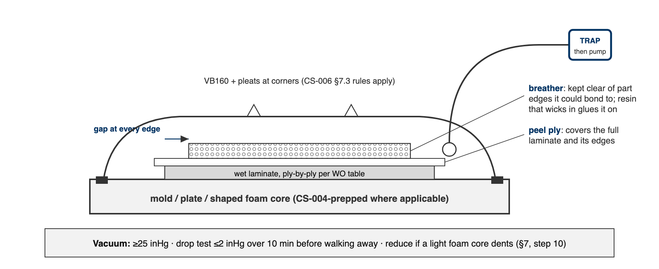
Figure 1. The wet-layup bag in section. The breather covers the peel ply but stops short of every part edge; resin that wicks into breather at an edge bonds it to the part.

7.5 Vacuum and drop test
- Pull to ≥25 inHg.
- Drop test before walking away: isolate the pump; the bag shall lose ≤2 inHg over 10 minutes. Record start and end readings on the WO. Leak hunting per CS-006 §7.7.
- On light foam cores, watch for vacuum crush: if the core dents, reduce vacuum and record the level that held on the WO, per part, so the next build starts from a number.
[ PHOTO: bagged wet layup under vacuum, pleats visible, gauge in frame ]

7.6 Cure and demold
- Leave bagged under vacuum overnight minimum. 206 reaches thin-film solid in 10–15 h at 72 °F (R1); a cold shop runs longer.
- Demold no earlier than the FEB hold for the system (CS-008 §5; the WO enforces it). Record times and masses on the WO; label the part per CS-001; hand to CS-009 for trim.

7.7 Foam-wrapped elements (RW E2–E5 class)
The same flow over a shaped foam core instead of a mold: wet plies wrap the core, then peel ply, breather, bag. The §7.5 crush rule is the one that bites here; everything else is unchanged.

8. Quality checks / acceptance criteria
Check | Target | Method | Record where
Vacuum | ≥25 inHg; drop ≤2 inHg/10 min | Gauge | WO
Wet-out | No white/dry weave visible | Visual per ply | WO
Mass | WO target ±10% | Scale | WO qualityChecks

9. Records
Same as CS-006 §9: times, masses, gauge readings, photos into the WO.

